**Development of an IOT based smart system for measuring dehydration levels**

Amogh Garg   
 *Dept. of Computer Science and Engineering* *Netaji Subhas University of Technology* New Delhi, India  
amoghgarg9@gmail.com

Mokshi Sharma  
 *Dept. of Computer Science and Engineering* *Netaji Subhas University of Technology* New Delhi, India  
mokshisharma1411@gmail.com

Shirishti Jain   
 *Dept. of Computer Science and Engineering* *Netaji Subhas University of Technology* New Delhi, India  
shirishti2002@gmail.com

*Abstract*— Dehydration is a major health concern that affects a large portion of the population worldwide. To address this issue, we propose an Internet of Things (IoT) based solution that can measure the dehydration level of the user. The system uses ultrasonic sensors to measure the water intake level and GSR sensors to measure water loss in the form of sweat. These sensors are connected to an Arduino Uno microcontroller, which is responsible for processing the data and transmitting the output to an LED and also to user device like mobile phones over WIFI. The LED displays the hydration level of the user, water intake and water loss at current time instance whereas graphical analysis is shown on the user device. The system can track the user's water intake over time, helping them to maintain a healthy hydration level. The proposed system offers a cost-effective and non-invasive method for monitoring dehydration levels and encouraging users to drink water regularly. Future work includes improving the accuracy of the hydration level measurements and integrating the system with other health monitoring devices to provide a comprehensive health monitoring solution.

Keywords - Dehydration, Ultrasonic, GSR, Hydration level, Arduino, Water intake, Water loss

# Introduction

The human body requires water to function correctly. However, dehydration remains a significant problem for many individuals, including the elderly and athletes. Proper hydration is crucial for maintaining optimal health, as dehydration can lead to a wide range of consequences such as fatigue, headaches, and decreased cognitive function. In severe cases, dehydration can even increase the risk of heat stroke and other heat-related illnesses, exacerbate existing health conditions such as kidney stones and urinary tract infections, and impact overall physical performance.

While there are various methods for monitoring hydration levels, such as observing the color of urine or undergoing laboratory tests, these methods are not always convenient or accurate. Further these methods are time consuming also and requires a lot of efforts from the user side. As a result, we have sought to develop innovative solutions to monitor hydration levels more effectively.

In recent years, the Internet of Things (IoT) has become increasingly popular, and its application in the health and wellness sector has become widespread. The IoT enables the integration of various devices and sensors, allowing the collection and analysis of health-related data. It is a network of physical objects that are embedded with sensors, software, and connectivity to exchange data with other devices and systems over the internet. These objects can be anything from everyday devices such as cars, household appliances, and wearables to industrial machines and sensors used in agriculture, healthcare, and manufacturing. The data generated by IoT devices can be used to make informed decisions and drive innovation in various fields, including healthcare, transportation, energy, and agriculture.

In this context, our research project aims to develop an IoT-based smart system that can monitor the hydration level of the user in real-time. The system is equipped with an ultrasonic sensor that measures the water level in the bottle, providing a precise measurement of water intake by the user. Additionally, a Galvanic Skin Response (GSR) sensor is used to measure water loss in the body through sweat. Skin conductance of the user is measured at periodic intervals by the GSR sensor, and this skin conductance value is converted to sweat rate, which is further used to calculate the water loss from the body in the form of sweat.

The collected data is then sent to an Arduino Uno, which analyzes and processes the data. The Arduino Uno is responsible for notifying the user of their water intake, water loss and hydration levels on a scale of 1-10 by sending the output to LED. Further the metrics can be analysed by the user easily in the form of graph which is shown on handheld devices like mobile phones or on laptops. This solution aims to reduce the gap between the prevention of dehydration and actually measuring the dehydration levels by integrating separate technologies of monitoring water consumption of an individual and total body water (TBW) loss measurement.

This research project is particularly significant because it addresses the complexities of hydration, taking into account factors like sweat rate that impact the loss of water from the body. By doing so, it aims to build a system that can be used expediently to measure the hydration level of the user. Overall, the proposed system has the potential to revolutionize the way we monitor and maintain hydration levels in our daily lives, improving overall health outcomes and preventing dehydration-related complications.

## Contributions

* Worked on an expedient method to measure water loss in the form of sweat.
* Demonstrated the use of GSR sensor to measure sweat rate.
* Measuring hydration level in real time based on water intake as well as loss.

The futuristic aim is to replace normal water bottle with the proposed smart water bottles capable of measuring the hydration level of the user in real time, therefore, making every individual who uses a water bottle in his/her daily life a potential target customer. This research paper aims to describe the development and implementation of the IoT-based system, including the design, testing, and results of the system. The paper also discusses the potential applications and future scope of the system, including its integration with other health-related IoT devices to provide a comprehensive view of the user's health status.

# LITERATURE REVIEW

Here, we have illustrated some related works which have been  conducted  by  the  researchers previously. We have studied the research works and tried to find out the limitations of the research such as the paper by Laxmi Lahari Jalagam, proposes a system for monitoring and tracking daily water intake using an IoT based smart water bottle [1]. This system measures the amount of water consumed by the user on the basis of the depth of the water in the bottle as measured by the ultrasonic sensor and gives them real-time feedback on their hydration status. With the help of NodeMCU, programming can be done, and an alarm is installed in the system in order to notify the user as to when he/she has to drink water. Using machine learning algorithms, the system provides personalised water intake recommendations based on various parameters like the user's age, weight, and activity level. The author concludes that the proposed system can be useful for promoting healthy hydration habits and preventing dehydration-related health issues. In spite of that, the paper notes that some limitations still exist, such as the need for a reliable Bluetooth connection and the costs of the components, which could make the system less accessible for some. Nam Eui Lee et al. proposed in their paper titled “A Smart Water Bottle for New Seniors: Internet of Things (IoT) and Health Care Services” - a smart water bottle system can be made to monitor the user's hydration status and provide reminders to drink water as needed [2]. It may be possible to design and develop a smart water bottle that includes sensors, such as weight sensors, temperature sensors, and humidity sensors, and a microcontroller and Bluetooth module to transmit data to a mobile application. It sends the user a reminder to drink water on a regular basis, as well as providing real-time hydration status information. The authors conducted a survey of 200 seniors to gather their opinions on the smart water bottle, and found that most seniors were interested in using it.

Sonali Vishwakarma et al. have developed an IoT-enabled water bottle that provides useful information about the amount of water consumed by users [3]. With the bottle's sensors, it is possible to detect how much liquid is inside, and it can send this information via Bluetooth to a mobile application.Following this, the mobile application displays information about the user's water consumption, including how much water was consumed, how much water remained, and reminders to drink more water.The use of iot technology is demonstrated here by using hardware and software such as the Arduino Uno board that  processes this information and transmit it to the mobile application via Bluetooth, Ultrasonic sensor to detect level of water in bottle,battery to charge the system. Sumit Kor et al. have also developed a similar system but with an added functionality of displaying the hydration level based on water intake with the help of LED [4].

Angga Edwin Wijanarko et al. have demonstrated that by combining fuzzy logic with the Internet of Things, everyday objects such as water bottles can be made more convenient and useful [5]. When the user drinks from the bottle, a touch sensor detects it and this information is transmitted to Raspberry Pi board that uses logic called fuzzy logic to measure the user's water consumption and via wifi transmit this data to the mobile. As a result of fuzzy logic, the system can make decisions based on uncertain or imprecise data, which comes in handy during situations that may have noisy or incomplete data. Based on the capacitive touch sensor data collected by the smart water bottle, fuzzy logic calculates the user's water intake.

However, these studies are focused on prevention of dehydration. But the need of the hour is to develop a system which can actually measure the hydration level of the user in real time and inform the user about the same. Above mentioned studies also don’t take into account the water loss from the body which is an important factor determining dehydration in a person. Falmouth Community Hospital has studied that although most developed countries have easy access to water, dehydration remains a significant problem, especially for certain groups such as the elderly and athletes [6]. Most of the people are not aware of how much water needs to be taken every day which causes dehydration. There are various other factors also such as temperature and the physical activities performed by an individual.It leads to various consequences such as fatigue, headaches, and decreased cognitive function increased risk of heat stroke and other heat-related illnesses, and exacerbation of existing health conditions such as kidney stones and urinary tract infections. One should always stay hydrated and should monitor the level of hydration by observing the colour of urine which should be pale yellow. Furthermore, increasing awareness and education about dehydration is necessary, especially for high-risk groups.

Andrew Breuk et al. developed a real-time wireless sweat rate measurement system that can measure sweat rate without the need of removing clothes [7].The system consists of a wearable device that has a small sweat sensor, a microcontroller, a Bluetooth module, and a battery. In this system the sensor is made up of polymeric material that absorbs sweat and changes its electrical resistance and then converted into sweat rate value by a microcontroller which is then transmitted wirelessly via Bluetooth to a receiver that may be a smartphone or tablet. Users can set up hydration goals and receive alerts when sweat rates exceed certain thresholds with the application, which displays sweat rate data in real-time.The results are found to be comparable to that of traditional methods.

Panigrahy Saroj Kumar et al.  discuss the study and analysis of human stress detection using a Galvanic Skin Response (GSR) sensor in wired and wireless environments [8]. The authors describe the setup of the experiment, which involves measuring GSR data using a sensor and analysing it to determine the level of stress of the subject. The study is conducted in both wired and wireless environments, and the results are compared. Pietro Salvo et al. have worked on the development of a wearable sensor for measuring sweat rate, which can be used for monitoring the hydration levels of athletes during physical activity [9]. The sensor utilises a miniaturised flow metre and a microcontroller to measure the rate of sweat production and wirelessly transmit the data to a smartphone app. The authors report high accuracy and reliability of the sensor in laboratory tests and suggest potential applications in sports science and healthcare. Tatsuro Amano et al. have studied the maximum rate of ion reabsorption in eccrine sweat glands by analysing the relationship between local sweat rate and galvanic skin conductance [10]. The researchers conducted experiments on 12 male participants exercising in hot and humid conditions, where their local sweat rate and skin conductance were measured using various techniques. The results showed that the relationship between sweat rate and skin conductance can provide information on the ion reabsorption rate of the sweat glands, which is an essential factor in maintaining electrolyte balance during sweating. The findings suggest that the technique could be useful in understanding the mechanisms of sweat gland function and for developing personalised hydration strategies for individuals engaging in physical activities in hot and humid environments.

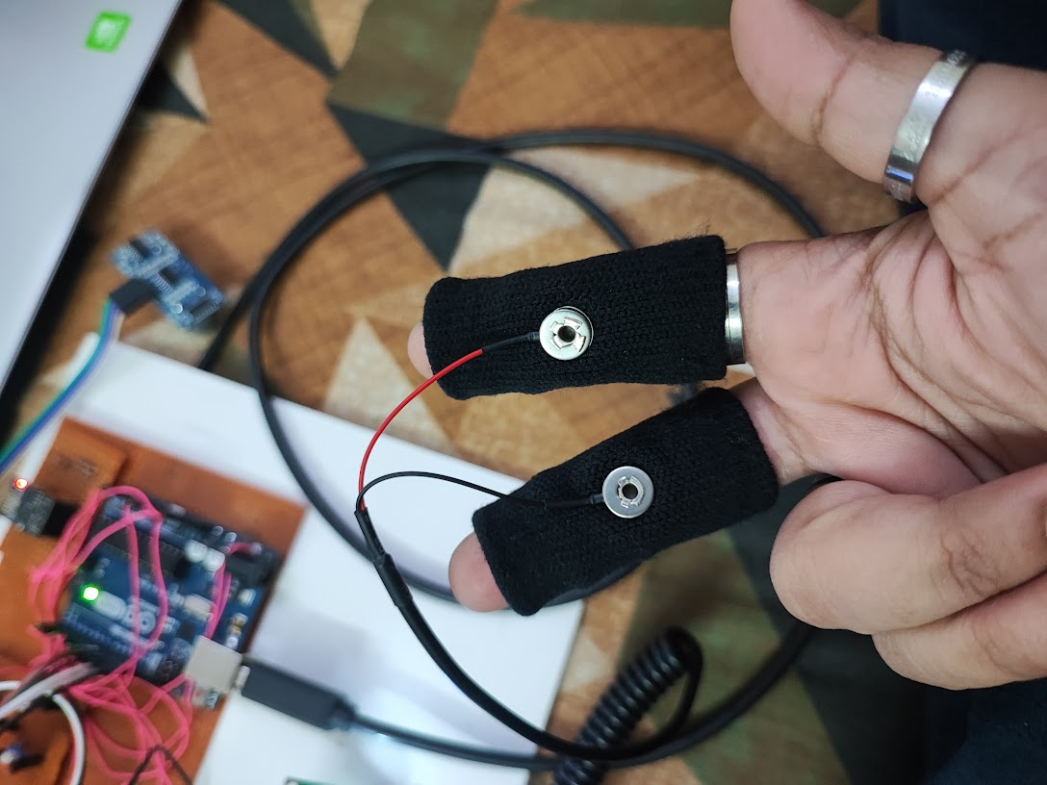

Fig. 2. GSR sensor measuring skin conductance

# SOLUTION

## Approach

The proposed system is designed to measure the hydration level of a user on a scale of 0-10 by continuously monitoring their water intake and water loss through sweat. This system considers the water loss from the body in the form of sweat thereby overcoming the limitations of the previous studies. The system uses an ultrasonic sensor to measure the water consumption of the user in real time. We have used ultrasonic sensors because they use sound waves to measure water level, which means that they do not come in contact with the water. This makes them less prone to wear and tear, and reduces the chances of contamination. Also, they can measure water level with a high degree of precision. They can detect water level changes as small as 0.5 mm, which makes them ideal for measuring water level in applications where accuracy is critical.

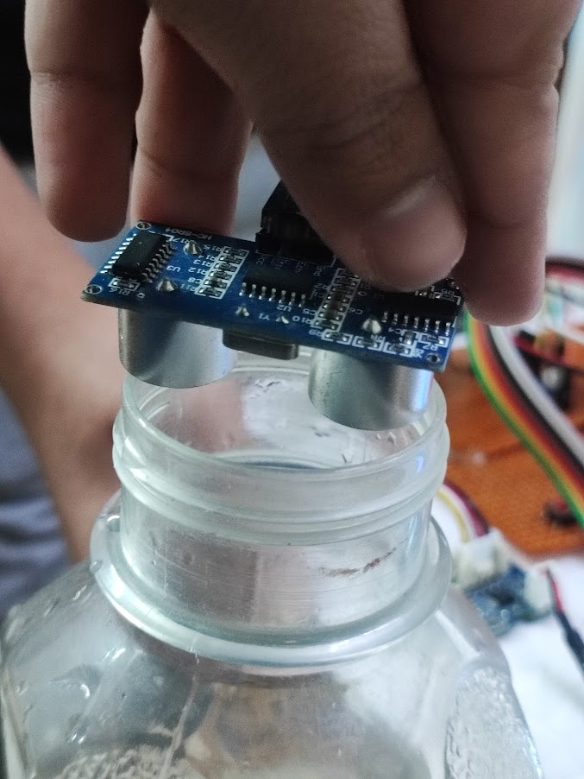

Fig. 1. Ultrasonic sensor measuring water level

There are some methods to measure the sweat rate of a person as mentioned in section-II. But these mechanisms are complex and costly. Therefore, we have thought of an easy to use and inexpensive method which incorporates Galvanic Skin Response (GSR) sensor to measure the sweat rate. It measures the electrical conductance of the skin, which changes as sweat is produced by the sweat glands and travels to the skin surface. The sweat contains charged ions, which increase the electrical conductance of the skin. The GSR sensor detects these changes in the skin's electrical conductance and converts them into a measurable signal. This signal is then used to calculate the sweat rate, which is the amount of sweat produced by the body per unit of time. The higher the electrical conductance of the skin, the higher the sweat rate, indicating greater water loss through sweat. GSR sensors provide us with a non-invasive and portable mechanism to measure sweat rate. They have been found to be accurate in measuring sweat rate, and can provide a reliable indication of hydration levels and also they are relatively inexpensive compared to other methods of sweat rate measurement, such as sweat patches or laboratory analysis.

Ultrasonic and GSR sensors are connected with Arduino Uno which processes the data and provides the users with information on their hydration levels in real time. The output like water intake, water loss and current hydration level is displayed on an LED. The user can also view the same information in graphical format on their mobile phones or laptops for better understanding and monitoring the data. The proposed system provides a simple and effective way for users to monitor their hydration levels and take appropriate action to maintain their health and well-being.

## Algorithm

## Pseudocode

// Global variable initialization

H = 0

// Main algorithm loop

while true:

// User consumes water (input in milliliters)

waterConsumed = inputWaterConsumed()

// Update hydration level

H = H + waterConsumed

// Measure skin conductance every hour

if isTimeForMeasurement():

// Measure skin conductance using GSR sensor

skinConductance = measureSkinConductance()

// Convert skin conductance to sweat rate

sweatRate = (4.3 * skinConductance) - 3.5

// Calculate water loss per hour

waterLossPerHour = sweatRate * 60

// Update total water loss

totalWaterLoss = totalWaterLoss + waterLossPerHour

// Adjust hydration level based on water loss

H = H - waterLossPerHour

// Calculate hydration percentage

hydrationPercentage = (H / 2300) * 100

// Calculate current hydration percentage

currentHydrationPercentage = (H / 96) * 100

// Calculate hydration level on a scale of 0-10

hydrationLevel = hydrationPercentage / 10

// Display hydration level

displayHydrationLevel(hydrationLevel)

// Check if 24 hours have passed to reset the monitoring cycle

if is24HoursElapsed():

H = 0

totalWaterLoss = 0

// Wait for the next iteration

sleep(1 hour)

In this section we have described the algorithm used for the hydration level monitoring system. First, a global variable H is created and initialised to 0. H basically denotes the hydration level of the user (not on a scale of 0-10). Whenever water is consumed by the user, the amount of water consumed by the user (in milliliters) is added to the value of H. Every hour, the user is supposed to measure the skin conductance using the GSR sensor. The skin conductance of the user is converted to sweat rate using the formula proposed by Amano et al. in their paper titled "Determination of the maximum rate of eccrine sweat glands’ [11]. The formula is:

*Sweat Rate(mg/min) = 4.3 X SC – 3.5* 

where SC is the skin conductance value in micro siemens.

Then the water loss per hour is calculated by multiplying the sweat rate by 60. The water loss per hour is added to the total water loss value. The next step is to subtract the total water loss from the value of H. Finally, H is converted on a scale of 0-10 using the below formula and the result is shown as the output.

*Hydration Percentage (HP) = (H/2300) X 100*  2

*Current Hydration % (CHP) = (H/96) X 100*  3

*Hydration Level (on scale 0-10) = HP / 10*  4

Where 2300 in (2) is the average amount of water intake requirement by an adult in milliliters per day and 96 in equation (3) is the average amount of water intake requirement by an adult in milliliters per hour. The global variables are reset every 24 hours to start a new monitoring cycle from a new day. In summary, the algorithm monitors the water intake and water loss of the user to determine their hydration level, which is displayed on a scale of 0-10. The use of the GSR sensor allows for accurate measurement of sweat rate, which is a key factor in determining water loss.

# RESULT ANALYSIS

## Experimental Setup

The setup used in the experiment was as described in Section-III and shown in Fig. 3. For testing the system water intake levels as well as the water loss levels were measured

frequently at intervals of 2 minutes for 10 minutes. In accordance with this the equation (3) was changed to:

*Current Hydration % (CHP) = (H/1.6) X 100*  (5)

Where 1.6 in the denominator is the average amount of water intake requirement by an adult in 2 minutes. The user was supposed to drink small amount of water sporadically over a period of 10 minutes and measure his/her skin conductance using GSR at approximate intervals of 2 minutes.

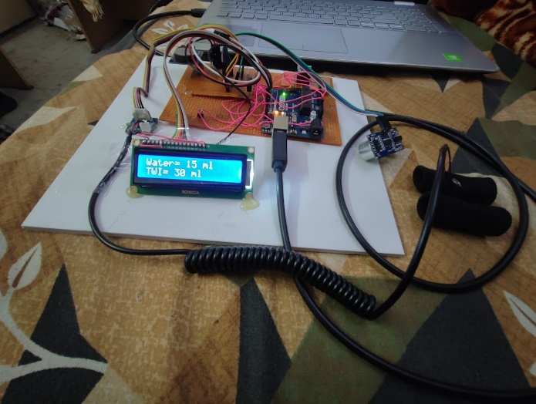

Fig. 3. System Setup used for testing

## Experimental Results

The experiment conducted resulted in successful measurement of the hydration level of the user. The ultrasonic sensor measured the water intake of the user in milliliters whereas the GSR sensor was used successfully to measure the water loss from the body in form of sweat by converting the skin conductance to sweat rate.

The water intake by the user as measured by the ultrasonic sensor was displayed on the LED as shown in Fig. 4. and the graph of water intake over time was displayed on the Blynk IOT app installed on the user’s smart phone as shown in Fig.5

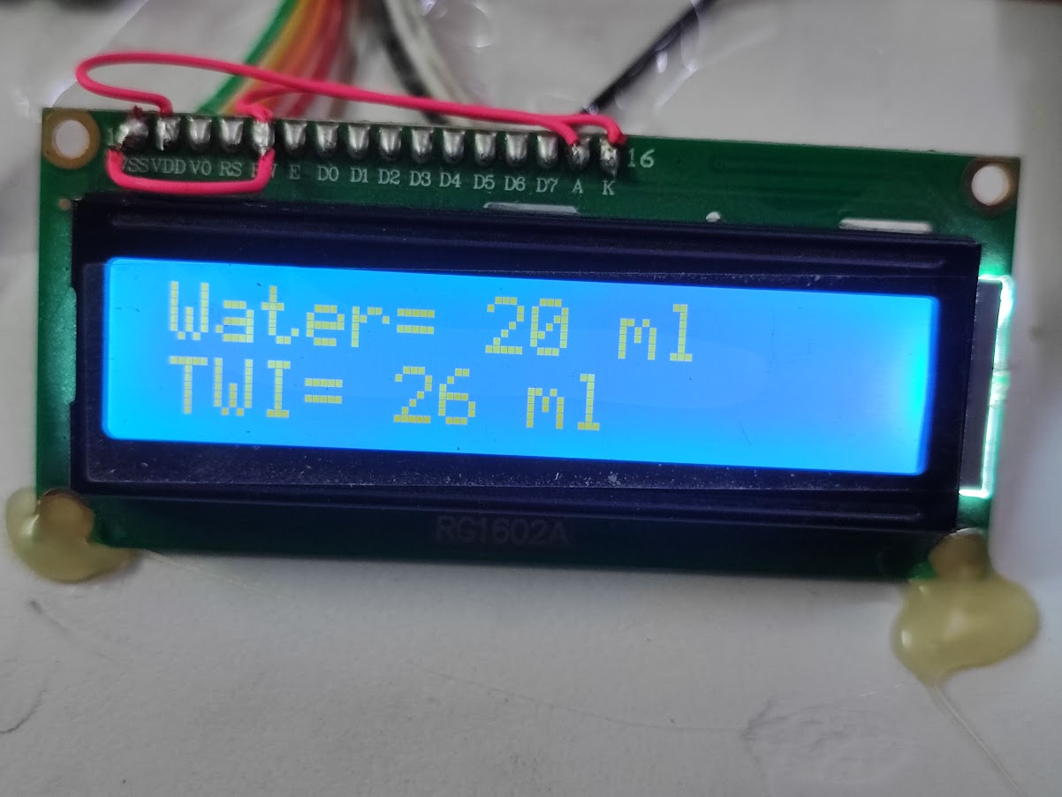

Fig. 4. Total Water Intake(TWI) at an instance of time being displayed on the LED screen

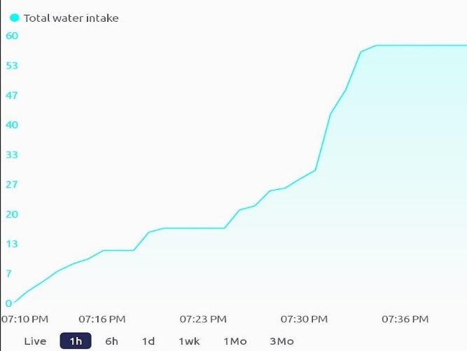

Fig. 5. Total water intake graph where x-axis denotes time and y-axis denotes water intake in milliliters

The graph of water loss in the form of sweat as measured by GSR sensor is as shown in Fig. 6.

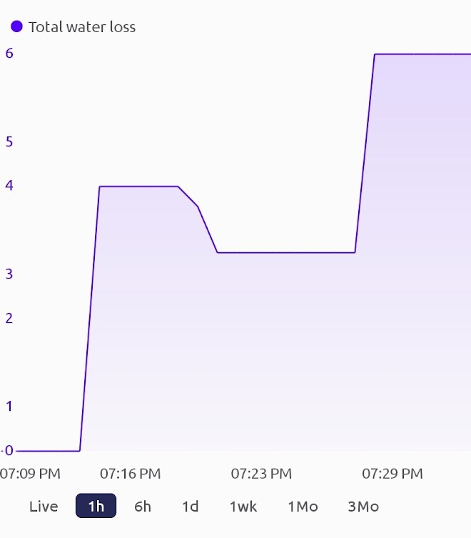

Fig. 6. Water loss graph where x-axis denotes time and y-axis denotes water loss in form of sweat in milliliters

Finally, the graph obtained for the hydration level of the user on a scale of 0-10 is shown in Fig. 7. The value 0 indicates that the user is completely dehydrated and the value 10 indicates that the user has met the average hydration level requirement for an adult during that duration. Hydration level values in the range 7-10 indicates that user is sufficiently hydrated, values in the range 4-6 indicates that the user is hydrated just enough and is suggested to drink more water. Values in the range 0-3 indicates that the user is at a high risk of dehydration and should immediately increase the water consumption.

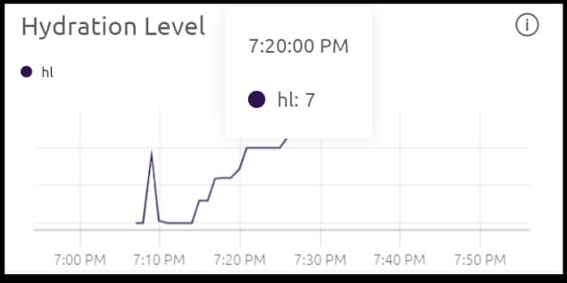

Fig. 7. Graph of hydration level where x-axis is the time and y-axis denotes hydration level on a scale of 0-10.

## Inference

From the conducted experiment we can confirm the following:

* The ultrasonic sensor successfully measured the water intake of the users at regular intervals of time. However, beyond a certain range ultrasonic sensors had difficulty giving accurate measurements.
* GSR sensor can be used to measure the water loss in the form of sweat by converting the skin conductance value to sweat rate.
* Real time hydration level was successfully calculated and the result were displayed on the LED and on the smart phones and laptops in graphical format for better analysis purposes.

# CONCLUSION AND FUTURE WORK

In this paper, we propose an easy to use, fast and cost-effective method to measure the personal hydration level in real time. We have used Arduino Uno, ultrasonic sensor and GSR sensor to build a system which can be used by anyone without personnel training. There are devices in the market which monitor the water consumption but there are no devices that measure the hydration of the user in the real sense. Current studies focus on the prevention of dehydration in a person by constantly reminding them to drink water, whereas there no convenient mechanisms to actually measure the hydration level of the person. Our approach aims to provide a continuous and accurate measurement of the hydration level of the user. The proposed system has several advantages over traditional methods of measuring hydration level, including its non-invasive and real-time nature. Additionally, the system can help users maintain optimal hydration levels, which is critical for overall health and well-being.

According to our tests, the system has been proven to be effective through extensive testing and evaluation. However, some trade-offs are made to maintain the cost-effective nature of the solution, which limits the performance of the devices, but we believe that such trade-offs are necessary to protect the original intention of the solution, which is to create a cost effective and easy to use product. However, certain components of the solution can be reasonably improved to increase the performance of the product. Laser sensor may be used in place of ultrasonic sensor to better accuracy of water intake measurement and also to increase the range in which the readings can be taken. We believe future work on making this system more compact and portable will prove advantageous. Overall, the proposed system proves to be an effective product in measuring the hydration level in real time and has the potential to significantly improve hydration management for individuals.

##### References

1. Jalagam, Laxmi Lahari, “IoT Based Smart Water Bottle” (July 23, 2021). Available at SSRN: <https://ssrn.com/abstract=3919060> or [http://dx.doi.org/10.2139/ssrn.3919060](https://dx.doi.org/10.2139/ssrn.3919060)
2. Nam Eui Lee, Tae Hwa Lee, Dong Heui Seo and Sung Yeon Kim, “A Smart Water Bottle for New Seniors: Internet of Things (IoT) and Health Care Services”, International Journal of Bio-Science and Bio-Technology Vol.7, No.4 (2015), pp.305-314
3. Sonali Vishwakarma, Anushree Goud, “ A Literature Review on: Smart Bottle using IOT”, International Journal of Computer Sciences and Engineering Vol.-7, Issue-6, June 2019
4. Sumit Kor, Rohit Shinde, Amol Bhosale, Dr. Vijay R. Sonawane, “IOT BASED SMART WATER BOTTLE”, International Research Journal of Modernization in Engineering Technology and Science Volume:04/Issue:06/June-2022
5. A. E. Wijanarko, M. Abdurohman and A. G. Putrada, "A Fuzzy Logic Based Internet of Things (IoT) for Smart Water Bottle," 2019 5th International Conference on Computing Engineering and Design (ICCED), Singapore, 2019, pp. 1-6, doi: 10.1109/ICCED46541.2019.9161100.
6. Campbell N. Dehydration: why is it still a problem, Nursing Times. 2011 Jun 7-13;107(22):12-15. PMID: 21761784.
7. Brueck, A.; Iftekhar, T.; Stannard, A.B.; Yelamarthi, K.; Kaya, T. A Real-Time Wireless Sweat Rate Measurement System for Physical Activity Monitoring. Sensors **2018**, 18, 533. <https://doi.org/10.3390/s18020533>
8. PS Kumar, JS Kumar, TA Kumar, “Study and analysis of human stress detection using Galvanic Skin Response Sensor in wired and wireless environments”, Volume: 10, Issue: 2, Year – 2017
9. P. Salvo, F. Di Francesco, D. Costanzo, C. Ferrari, M. G. Trivella and D. De Rossi, "A Wearable Sensor for Measuring Sweat Rate," in IEEE Sensors Journal, vol. 10, no. 10, pp. 1557-1558, Oct. 2010, doi: 10.1109/JSEN.2010.2046634.
10. Amano, T., Gerrett, N., Inoue, Y. *et al.* Determination of the maximum rate of eccrine sweat glands’ ion reabsorption using the galvanic skin conductance to local sweat rate relationship. *Eur J Appl Physiol* **116**, 281–290 (2016). <https://doi.org/10.1007/s00421-015-3275-9>
11. Amano, “Determination of the maximum rate of eccrine sweat glands ion reabsorption using the galvanic skin conductance to local sweat rate relationship”, Physiological Measurement, 2017

|  |  |  |  |  |
| --- | --- | --- | --- | --- |
| |  |  |  |  | | --- | --- | --- | --- | | |  |  |  | | --- | --- | --- | | |  |  | | --- | --- | | |  | | --- | |  | | | | |